Class 6: R functions

Alberto Carreno

1/24/2020

## R Markdown

## this is a level 2 heading

x <- c(1:10)  
x

## [1] 1 2 3 4 5 6 7 8 9 10

here is my analyssis , the mean fof your data is 5.5

this is **regular** old *text*!

and a list of stuff

plot(1:5, col = "blue", type = "o")

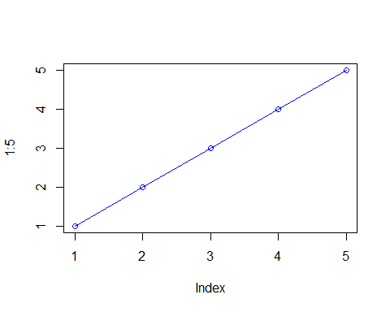

-a thing -another thing -and a third

### this is a level 3 heading

## more on reading input files

we will use the read.table() function again

This is an R Markdown document. Markdown is a simple formatting syntax for authoring HTML, PDF, and MS Word documents. For more details on using R Markdown see <http://rmarkdown.rstudio.com>.

When you click the **Knit** button a document will be generated that includes both content as well as the output of any embedded R code chunks within the document. You can embed an R code chunk like this:

summary(cars)

## speed dist   
## Min. : 4.0 Min. : 2.00   
## 1st Qu.:12.0 1st Qu.: 26.00   
## Median :15.0 Median : 36.00   
## Mean :15.4 Mean : 42.98   
## 3rd Qu.:19.0 3rd Qu.: 56.00   
## Max. :25.0 Max. :120.00

## Including Plots

You can also embed plots, for example:



Note that the echo = FALSE parameter was added to the code chunk to prevent printing of the R code that generated the plot.

x <- read.table("test1.txt" ,header = TRUE, sep = ",")  
x

## Col1 Col2 Col3  
## 1 1 2 3  
## 2 4 5 6  
## 3 7 8 9  
## 4 a b c

y <- read.table("test2.txt", sep = "$", header = T)  
y

## Col1 Col2 Col3  
## 1 1 2 3  
## 2 4 5 6  
## 3 7 8 9  
## 4 a b c

z <- read.table("test3.txt")  
z

## V1 V2 V3  
## 1 1 6 a  
## 2 2 7 b  
## 3 3 8 c  
## 4 4 9 d  
## 5 5 10 e

##Time to work on functions!

add <- function(x,y = 1){  
 x+y  
}

add(c(1,2,3),22)

## [1] 23 24 25

a <- range(c(1,2,3,4))  
a[2]

## [1] 4

rescale <- function(x){  
 rng <- range(x)  
 (x-rng[1])/(rng[2] -rng[1])  
}

rescale(c(1:10,30,100))

## [1] 0.00000000 0.01010101 0.02020202 0.03030303 0.04040404 0.05050505  
## [7] 0.06060606 0.07070707 0.08080808 0.09090909 0.29292929 1.00000000

x <- c(1:10)  
rng <- range(x,na.rm = T)  
rng

## [1] 1 10

rescale2 <- function(x){  
 rng <- range(x, na.rm = TRUE)  
 (x-rng[1])/(rng[2] -rng[1])  
}

rescale(c(1:10,NA))

## [1] NA NA NA NA NA NA NA NA NA NA NA

rescale2(c(1:10,NA))

## [1] 0.0000000 0.1111111 0.2222222 0.3333333 0.4444444 0.5555556 0.6666667  
## [8] 0.7777778 0.8888889 1.0000000 NA

rescale(c(1,10,NA))

## [1] NA NA NA

rescale2(c(1,10,NA))

## [1] 0 1 NA

rescale3 <- function(x, na.rm=TRUE, plot=FALSE) {  
 if(na.rm) {  
 rng <-range(x, na.rm=na.rm)  
 } else {  
 rng <-range(x)  
 }  
 print("Hello")  
 answer <- (x - rng[1]) / (rng[2] - rng[1])  
 print("is it me you are looking for?")  
 if(plot) {  
 plot(answer, typ="b", lwd=4)  
 }  
 print("I can see it in ...")  
 return(answer)  
}

rescale3(x)

## [1] "Hello"  
## [1] "is it me you are looking for?"  
## [1] "I can see it in ..."

## [1] 0.0000000 0.1111111 0.2222222 0.3333333 0.4444444 0.5555556 0.6666667  
## [8] 0.7777778 0.8888889 1.0000000